Put the title Dissolution of the Monasteries in your exercise book.

Read the information on the webpage.

Task One
1. Working in a small group or as a whole class, discuss first Sources 1-4.
- Find TEN ways the monks were accused of behaving badly.
- What evidence is there that the inspectors were trying to find instances of bad behaviour?
2. Next, study Source 5.
- How does this Source support the suggestion that the monks’ behaviour was just an ‘excuse’ to close the monasteries (as Peter Moss said).

Task Two
1. Working in a small group or as a whole class, discuss the information in the Introduction.
- Find FOUR possible reasons why Henry closed down the monasteries.
- Rank them in a sensible order-of-importance – try to find evidence to support your ideas, rather than just ‘how you feel’.
2. Do the worksheet, Dissolution Because….
3. Do the worksheet, Because… Because… Because….

Task Three
1. Working in a small group or as a whole class, return to the information in the Introduction.
- Find FIVE consequences/effects of Henry’s dissolution of the monasteries.
2. Do the worksheet, Dissolution Results….

Task Four
1. Working as a whole class, discuss Source 6. The artist clearly sympathised with the monks.
- Find as many ways as you can that in his painting he makes you dislike the King’s inspectors, and makes you feel sorry for/like the monks There are at least FIFTEEN).
2. Discuss how YOU interpret the Dissolution.
3. Finally, discuss as a whole class this idea:
‘Henry’s break with the Catholic Church was about the succession, not about religion.’
Dissolution Because…

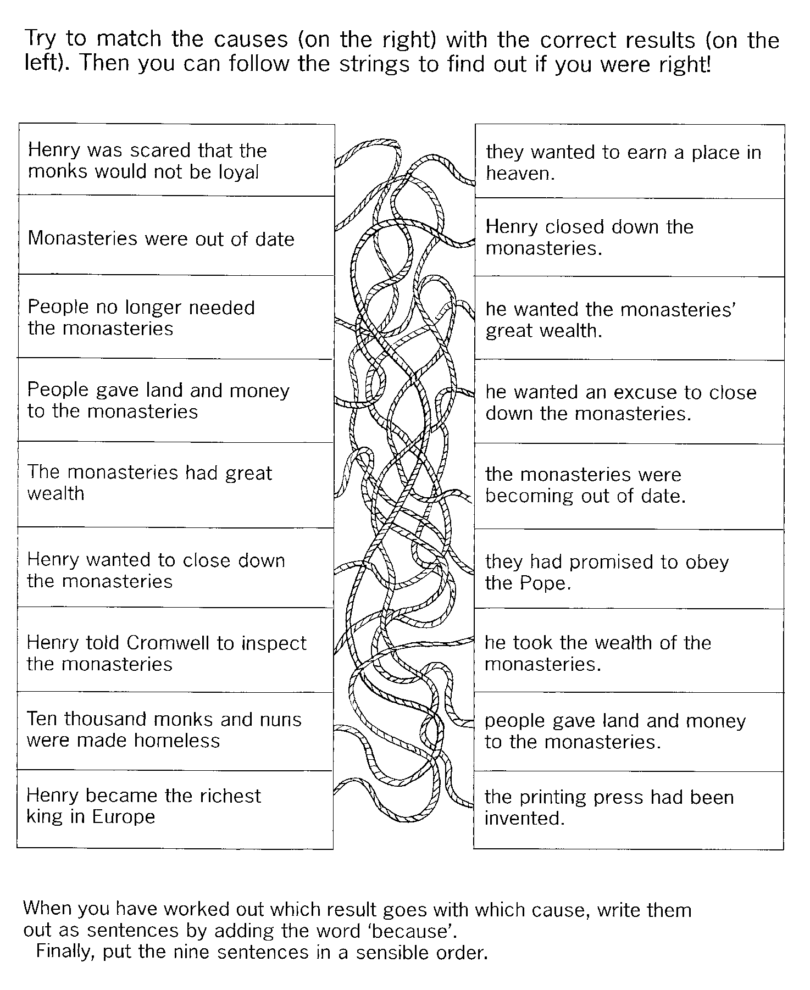
Because… Because… Because…

Cut this sheet into separate sentences along the lines.
Try to arrange two of them so that one follows on from the other.
Can you find any other sentences which go together in this way?
Try to put MORE than two sentences together like this.
What is the longest number you can join together in a logical sequence?

Henry was scared that the monks would not be loyal because they had promised to obey the Pope.
Monasteries were out of date because the printing press had been invented.
People no longer needed the monasteries because the monasteries were becoming out of date.
People gave land and money to the monasteries because they wanted to earn a place in heaven.
The monasteries had great wealth because people gave land and money to the monasteries.
Henry wanted to close down the monasteries because he wanted the monasteries' great wealth.
Henry told Cromwell to inspect the monasteries because he wanted an excuse to close down the monasteries.
Ten thousand monks and nuns were made homeless because Henry closed down the monasteries.
Henry became the richest king in Europe because he took the wealth of the monasteries.

Dissolution Results…

This diagram gives several consequences of closing down a monastery.

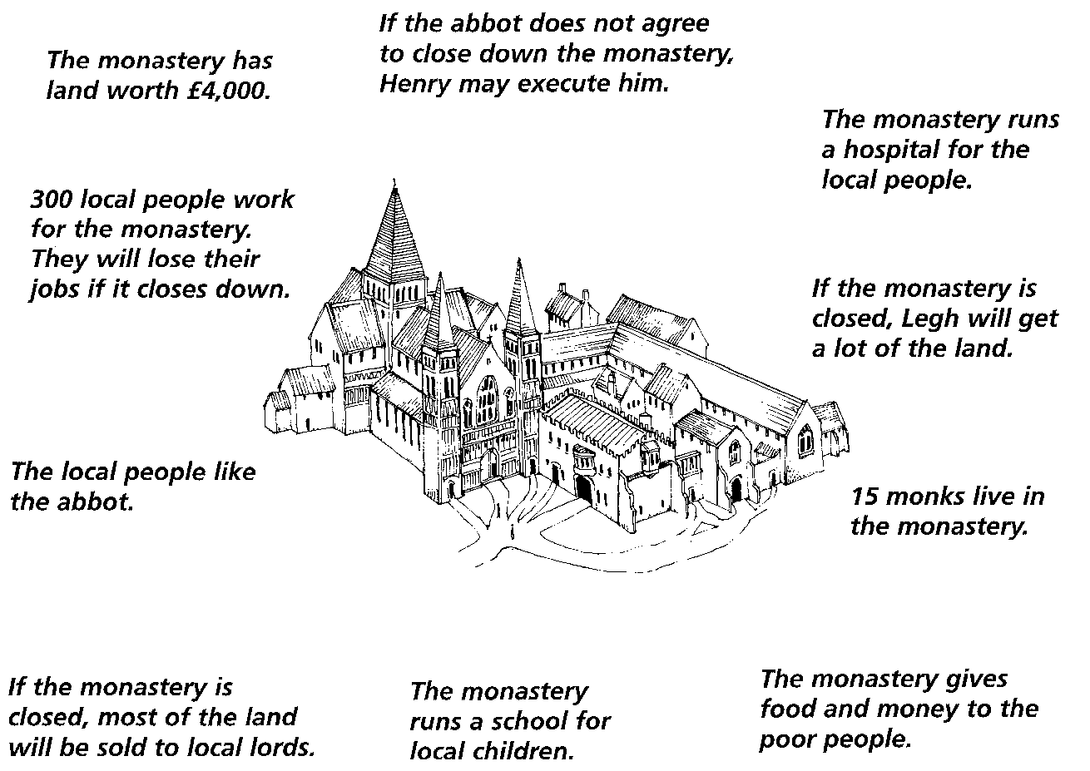

Working in a small group:

1. Discuss how the closure of the monastery would affect each of the following:.
- The monks
- A local poor woman
- A local lord
- A local child
- The Abbot
- A sick man
- Local labourers
2. Choose TWO of the above and write for each, as though you were they:
I am ……………………………………
I do/do not want the monastery to close because…………...

