Put the title Catholics v Protestants in your exercise book.

Read the information on the webpage, then:

Task One
1. Working with a partner or in a small group, play a game of ‘Spot the Difference’ between the churches in 1533 and 1570 in Source 1. (Do not try to explain why the church changed – you will do that later.)
2. Still working as a small group, study the section of the webpage ‘Introduction – continued’:
- Explain the derivation of the word: ‘Protestant’
- Explain the derivation of the word: ‘Reformation’
3. Still working in your group, study the table in Source 2. It is hard for us today to understand why people were prepared to kill each other over these differences. We have to realise that, for Tudor people, this was a matter of eternal life or eternal damnation.
- Go through the nine differences; for each, try to understand why Catholics found Protestant views so confrontational, and why Protestants found the Catholic beliefs so unacceptable.
- Try to link back the Protestant beliefs to the changes you noticed in the church; can you explain any of the differences in the 1570 church by referring to what Protestants believed?
4. Do the worksheet ‘Catholics and Protestants’ to cement your understanding of the differences between Catholics and Protestants.

Task Two
1. Coming together as a whole class, share your ideas. What were the main issues of contention between Catholic and Protestant? Why they were prepared to kill each other over them?
2. Did you consult any of the linked websites? Did you find any of your own?
- Which ‘good’ sites did you find (and why did you think them ‘good’)?
- Did you find any poor or useless sites (and why did you think them ‘bad’)?

Answers:
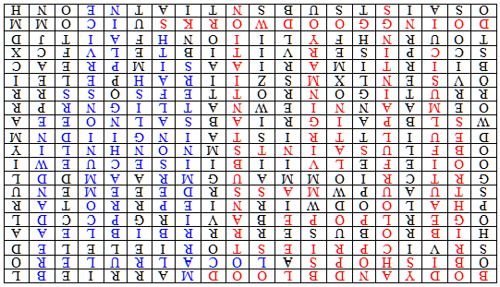
Catholics and Protestants
Using the webpage to help you, find and colour in the words which describe what Catholics believed in (red), and what Protestants believed in (blue), then write them in a list underneath the grid.

B | O | D | Y | A | N | D | B | L | O | O | D | M | A | R | R | I | E | B | L
O | B | I | S | H | O | P | S | A | L | O | C | A | L | R | U | L | E | R | O
S | R | V | I | C | P | R | I | E | S | T | O | R | I | E | L | E | L | E | D
H | I | B | R | O | B | U | S | E | R | R | R | R | B | I | B | L | E | A | A
O | G | E | R | L | P | O | P | E | B | A | V | I | R | G | P | C | C | D | L
P | H | A | L | O | O | D | W | I | R | N | I | E | P | R | R | O | T | A | R
S | T | U | A | U | P | W | M | A | S | S | R | D | E | E | E | M | E | N | U
G | R | T | C | R | I | O | M | M | A | U | G | M | R | A | A | M | D | D | L
O | O | I | E | F | E | L | V | I | I | B | I | I | S | E | C | U | E | W | I
O | B | F | L | U | S | A | I | N | T | S | M | N | O | N | H | N | L | I | Y
D | E | U | I | L | T | T | R | I | S | T | A | I | N | G | I | I | D | N | M
W | S | L | B | P | A | I | G | R | I | A | B | S | A | L | N | O | E | E | A
O | E | M | A | A | N | N | I | E | W | N | A | T | L | I | G | N | R | P | R
R | R | U | T | I | G | O | N | R | O | T | T | E | F | S | Q | S | S | R | R
O | V | S | E | N | L | X | M | S | Z | I | I | R | A | H | P | E | L | E | I
B | I | I | R | T | I | M | A | R | I | A | A | S | I | M | P | R | E | A | C
S | C | C | P | I | S | E | R | V | I | T | I | B | T | E | L | V | F | C | X
T | O | U | R | N | H | F | Y | L | I | I | O | N | H | F | A | I | T | J | D
D | O | I | N | G | G | O | O | D | W | O | R | K | S | U | I | C | O | M | M
O | S | A | I | S | T | S | U | B | S | N | T | I | A | T | N | E | O | N | H

Catholics believed in: | Protestants believed in:
- ___________________________________ | - ___________________________________
- ___________________________________ | - ___________________________________
- ___________________________________ | - ___________________________________
- ___________________________________ | - ___________________________________
- ___________________________________ | - ___________________________________
- ___________________________________ | - ___________________________________
- ___________________________________ | - ___________________________________
- ___________________________________ | - ___________________________________
- ___________________________________ | - ___________________________________
- ___________________________________ | - ___________________________________
- ___________________________________
- ___________________________________
- ___________________________________

